SIMATS ENGINEERING (SAVEETHA SCHOOL OF ENGINEERING) Department of Computer Science and Engineering
ASSESSMENT TOOL 1 – Constraint-Based Problem Solving
Course Code: | CSA06 | Course Title: | Design and Analysis of Algorithms
CO Assessed: | CO5– Naturalization (BL5,BL6) | Assessment: | Assessment Tool 1 – Constraint Based Problem Solving
Weightage: | 30% of CIA | Total Marks: | 100
CO5 Statement: | Analyze computational problems using backtracking techniques and complexity classes such as P, NP, NP-Hard, and NP-Complete for combinatorial problem solving.
Student Name: | R.NANDHINI | Reg. No.: | 192524355
Section / Batch: |  | Date:

Instructions to Students
• Answer the following question. Total Marks: 100.
• Apply backtracking techniques systematically for combinatorial problem solving.
• Clearly classify problems under P, NP, NP-Hard, and NP-Complete categories wherever required. • Provide proper justification, state-space representation, and complexity analysis for all solutions. • Neat presentation and logical explanation are mandatory.

Question Type | Focus Area | Questions
Constraint Based  Problem Solving | Analyze combinatorial problems using backtracking and complexity classes such as P, NP, NP-Hard, and NP Complete. | Q1

CODE:
n = int(input())
a = [list(map(int, input().split())) for _ in range(n)]

best = 999999
v = [False] * n
v[0] = True

def tsp(city, count, cost):
global best
if count == n:
best = min(best, cost + a[city][0])
return

for j in range(n):
if not v[j]:
v[j] = True
tsp(j, count + 1, cost + a[city][j])
v[j] = False

tsp(0, 1, 0)
print(best)

OUTPUT:
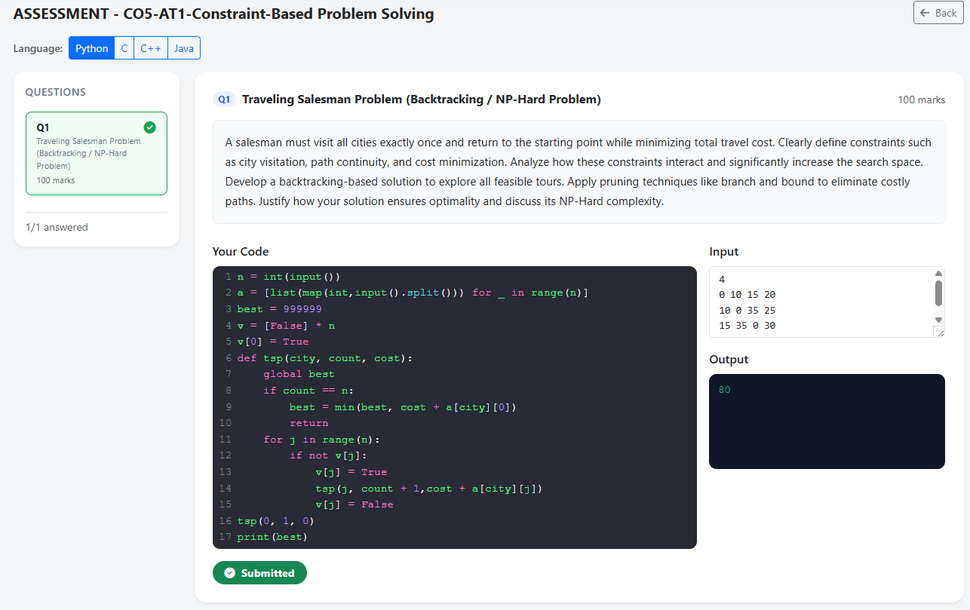
SECTION A – CONSTRAINT-BASED PROBLEM SOLVING
Code of Conduct
I __________________________ (Name / Reg No) certify that this submission is my original work and that I have adhered to the guidelines specified for this assessment. I understand that any violation of academic integrity rules will result in disciplinary action.
Signature of the Student: _________________________

RUBRICS FOR CALCULATION
Criteria | Wt. | Level 4 – Exemplary | Level 3 –  Proficient | Level 2 –  Developing | Level 1 –  Beginning
Problem  Understanding | 25% | Clearly defines the  problem and identifies all relevant constraints  accurately | Identifies most  constraints with  minor gaps | Partial understandi ng; misses key  constraints | Fails to identify constraints  correctly
Constraint  Analysis | 25% | Analyzes constraints  effectively and prioritizes them logically | Provides reasonable analysis with some prioritizatio n | Limited analysis; weak prioritization | No meaningful analysis or  prioritization
Solution  Development | 25% | Develops optimal and feasible solutions  satisfying all constraints | Develops workable solutions with minor limitations | Solutions partially  satisfy constraints | Solutions do not meet constraints
Application of Concepts | 15% | Effectively applies  appropriate concepts, methods, or tools | Applies concepts  with minor errors | Limited application; requires guidance | Unable to apply relevant  concepts
Justification | 10% | Provides strong  justification for decisions with logical reasoning | Provides justification with some clarity | Weak or unclear  justification | No justification provided

Marks Evaluation:
Criteria | Wt. | Level 4 –  Exemplary | Level 3 –  Proficient | Level 2 –  Developing | Level 1 –  Beginning
Problem Understanding | 25%
Constraint Analysis | 25%
Solution Development | 25%
Application of Concepts | 15%
Justification | 10%
Total Marks (100):

Faculty In-charge | Course Coordinator | Head of Department
Name: | Name: | Name:
Signature: _______________ | Signature: _______________ | Signature: _______________
Date: ___________________ | Date: ___________________ | Date: ___________________

